pwd:-will print the current working directory

Tab keypress while typing directory name will autocomplete the line for you.

node index.js

-runs the .js file in the command line

Node REPL

* if you write node and hit enter on the command line, you can write js code directly on the command line and execute it.
* It will work similarly to the browser console
* Write “**ctrl+C**” two times for exiting or wirte .exit

Tab double keypress

* Gives u all the possible things you can write at that point

Clear

* Deletes all the previous commands

nodejs.org/api/

* You can see all the native node modules and the documentation on how to use them
* 
  + Allows you to copy file1.txt contents to file2.txt

npm init

-creates the .json package for your project

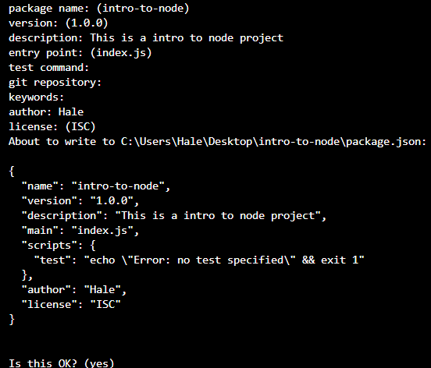

npmjs.com

* A package manager for external modules
* We can search for packages to use
* For example, the superhero package can be used as such
  + First, we will write npm install superheroes
  + Then we will add the below content and apis in our index.js file
    - 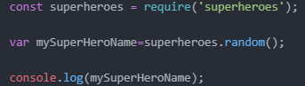
  + Then we will type node index.js. This will print the superHeroName in the command line
    - 